Watlington Primary School Home Learning Grid Reception Term 4 Jungle Scrumble
During term 4 we would like you to focus your home learning on developing your reading, speaking / listening and maths skills.
Please select one activity from the MUST section. For an additional challenge select an activity from the COULD section.
YOU DO NOT NEED TO COMPLETE EVERY ACTIVITY.

MUST  As well as choosing one activity from this section please ensure you complete……  daily reading (record in the yellow reading record). | Jungle Scrumble By Kirstie Watson and Tilia Rand Bell I Storytime Read Aloud (youtube.com)  Take a look at the story online, if you don’t have the book at home. Enjoy!  Try to watch at least once all the way through so you get to know the story well. | Our new book is set in the rainforest. What is a rainforest? What grows there/ What lives there? Can you go to the library and find a book about the rainforests?  Can you draw or paint a picture of the rainforest or of a rainforest animal? | Practise counting in 2’s….. how many pairs can you find at home to count in 2’s?  Can you count pairs of socks or gloves?  Can you line up cars or toys and count them in 2’s?
 | Rainforest Research  Where are rainforests found in the world?  What does it sound like in a rainforest?  Who lives in the rainforest?  Does it always rain there?  Write a rainforest fact OR come in and tell your teacher a fact you have learnt about the rainforest. | Practise saying the sounds in our phonics from your grid on the class page.  You could try putting them into a word.  You could find things at home starting with this letter sound. |   Grown-ups please check your child is working towards holding their pen / pencil in a comfortable grip. By the end of the year this is usually the pincer grip.
What is a rainforest habitat? - BBC Bitesize

Watch this clip for more information. Try the activity and quiz to test your knowledge.
 | Growing  You could try growing a plant. In rainforests plants grow super-fast! Why is this?  Can you plant a seed and watch it grow?  How will you help it to grow super-fast? | 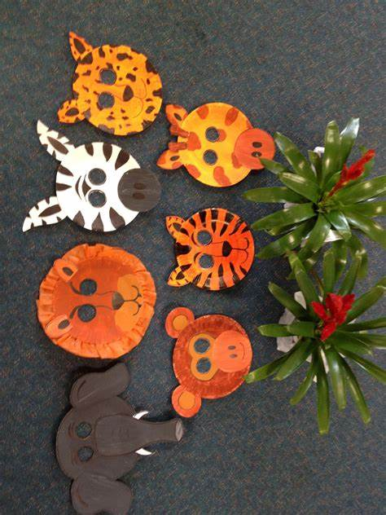  You could try making a paper plate animal - choose a bird  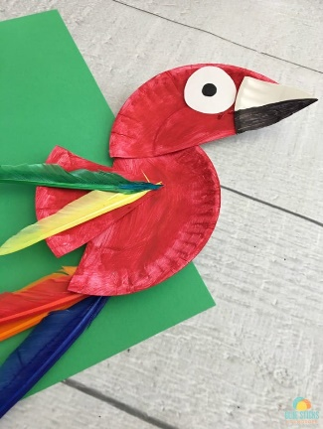  fish or animal that makes its home  in the rainforest.  