
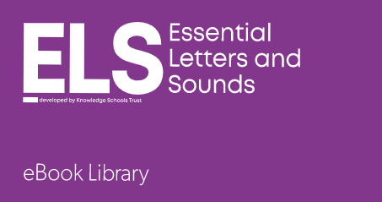
30/07/2026

eBook Library for Letters and Sounds

Guide for Parents
The eBook Library for Letters and Sounds is a step-by-step synthetic phonics teaching framework. The eBook Library for Letters and Sounds contains 100 books precisely matched to each of the phonics teaching sets. It means that your child can enjoy reading books that practise the exact grapheme-phoneme correspondences that they have just been taught by their teacher that week.

Books will be allocated based on the sounds being taught in phonics that week. For more targeted reading based on your child’s reading colour/level, please refer to the back of your child’s current reading book.

There will be review weeks, so not all weeks will have a new book assigned to them.

Your child’s log in has been stuck into their home learning book.
- Log in via www.oxfordowl.co.uk

- Click on the ‘Oxford Owl for Schools’ pink login button

- Click on the ‘Students’ tab and enter your username and password.

- Enter your school code

- Click on the purple ‘ELS’ icon to find the books that have been assigned.

Then click on students and add the log in details.

If you have any issues, please speak to your class teacher.

