Pirates

Introduction

Pirates are the most feared people to sail the Seven Seas. Do you want to know more about pirates? Then read on to find out more!

A Pirate’s Appearance

Swashbuckling pirates wear a bandana to keep their hair out of their face. They don’t have anywhere to wash so they have long matted hair and beards, and can be very stinky! Pirates often 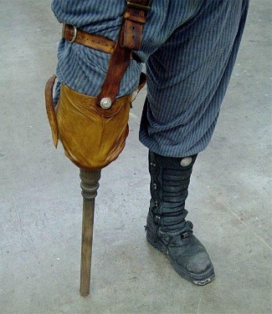have injuries from their hard lives so they may have stiff wooden legs and black eye patches. These salty seadogs carry a cutlass to fight their enemies.

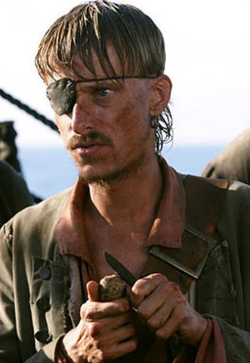

A Pirate’s Beliefs

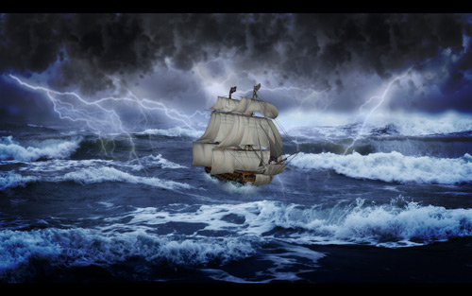Pirates carry a colourful parrot around for good luck! They pierce their ears as they believe it improves their terrible eyesight! Unbelievably, they also think having women on board is bad luck, so 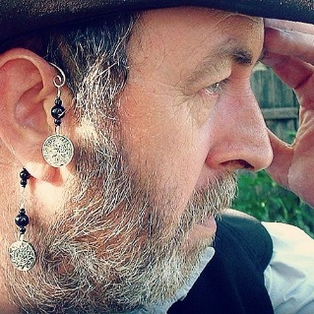they are cruelly banned from coming aboard. Even whistling isn’t allowed as they believe it will turn the weather stormy!

A Pirate’s Life on a Ship

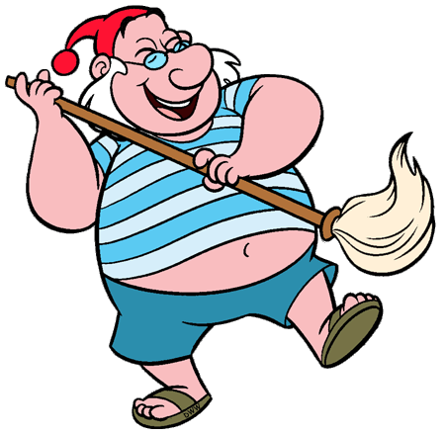A pirate’s home is their ship, however life on a pirate’s ship is hard. They spend hours mopping the dirty, wooden deck and eating poor food, which often leaves pirates hungry and ill.