ENGLISH | MATHEMATICS |  |  | SCIENCE |  |  | COMPUTING
Fiction: ‘Tom and the Island of Dinosaurs’  And ‘The Kindest Red’  Non-fiction: Instructions  Reading: ‘Marv and the Dino Attack’ | Fractions (1/2 and 1/4)  Position and Direction  Place value within 100  Money  Time |  |  | Animals including Humans  Children will continue to learn about the classification groups for animals: mammals, fish, birds, reptiles and amphibians. They will learn about the different diets animals eat. Children will learn about the parts of the human body and the five senses. |  |  | Programming  We will look at some simple on-screen programing using ScratchJr.
HISTORY |  | Dinosaurs  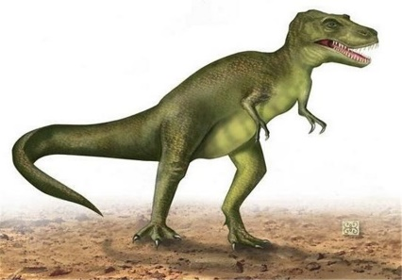 |  |  |  | GEOGRAPHY
To find out about the periods of time in which dinosaurs lived, investigate evidence to form our own opinions about how dinosaurs lived, identify why we think they became extinct, and learn about Mary Anning and her role in identifying and investigating the process of fossilisation. |  |  |  |  |  | We will locate continents on a map and discover the land mass where dinosaurs lived.
PHYSICAL EDUCATION | Art |  | MUSIC |  | PSHE/ Jigsaw |  |  | RE
Cricket  Children will learn how to become a bowler, a striker, a catcher and a scorer as we start to learn about the sport of cricket.  Athletics  Children will develop the fundamental elements associated with athletics - running, jumping and throwing, in preparation for our Sports Day. | Clay  We will use clay to create our own dinosaur fossils  Painting  We will create dinosaur silhouettes using paint to create striking backgrounds. |  | Charanga – ‘Reflect, rewind and replay’  We will listen and appraise a range of classical music. |  | Changing Me  We will begin to understand that changes happen as we grow and that growing up is natural. We will look at ways to cope with changes and how to learn new things. |  |  | Stories – Christianity  What makes some stories so important to different people?  We will discuss what stories are special to you and what makes them special.  We will look at why stories are important to some religious people and why.

