English | Maths | Science | Computing
Text – ‘Windrush Child’ by Benjamin Zephaniah  Non – fiction – Biography  Fiction: Journeys/flashbacks  Poetry: Benjamin Zephaniah  Reading – Vocabulary, inference, prediction, explain and summarise.  Grammar – Recap of previous learning. | Algebra  Use simple formulae and generate linear number sequences.  Express missing number problems algebraically.  Ratio and proportion  Solve problems involving the relative sizes of two quantities where missing values can be found by using integer multiplication and division facts. | Light  Use the idea that light travels in straight lines to explain that objects are seen because they give out or reflect light into the eye.  Electricity  Associate the brightness of a lamp or the volume of a buzzer with the number and voltage of cells used.  Use recognised symbols when representing a simple circuit. | Use search technologies effectively, appreciate how results are selected and ranked.  Use technology safely, respectfully and responsibly.  Understand computer networks including the internet; how they can provide multiple services, such as the world wide web; and the opportunities they offer for communication and collaboration.
History | 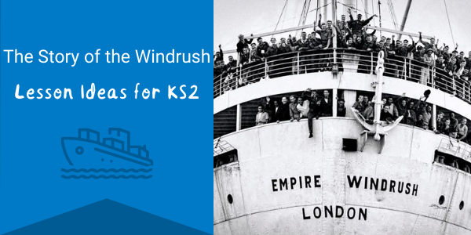  Diversity, Equality and Inclusion:  The Windrush |  | Geography
Windrush  Learn about the Windrush generation and how this key event in British history changed communities, food, music and even laws around the country. |  |  | Gain an overview of the geography of the Caribbean:  - Countries  - Location  - Climate  - Human and physical features  - Comparison with the UK
PE | Art / Technology | Music | PSHCE
Athletics  Develop flexibility, strength, technique, control and balance  Football  Defending/attacking  Footwork, ball skills | Artist: Hurvin Anderson  Art exploring the Caribbean culture and landscapes. | Ukulele  Play musical instruments with increasing accuracy, fluency, control and expression.  Use and understand staff and other musical notations. | Jigsaw term 6  Changing me – coping positively with changes.
RE  What matters most – an overview of all key religions. |  | French  ‘My home’ and ‘The Olympics’

