Watlington Primary School Home Learning Grid Year 1 Bats Class Term 1 ‘Kings and Queens’
Weekly | Reading: Daily – please record in your child’s yellow reading journal every time you hear your child read.
 | Learning Opportunities
Reading  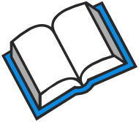 | Read some fiction books about Kings and Queens. Who are the characters?  Where is the book set?  What did you like or dislike about the story?  Can you write a book review to share with the class?  Can you predict a new ending?  Discuss the setting and characters.  Compare two stories about royalty. What is the same/different? | Can you read a book and then perform it as a play to an audience? We would love to see your drama skills if your performances can be recorded. Remember to act using your hands and bodies, as well as using expression in your voice and on your face. | Read a new genre of book.  Try a non-fiction book about Kings and Queens.  What did you like or dislike about it? What have you learnt? How do you know these facts are accurate? What is the best way to learn about history?
Phonics/  Writing  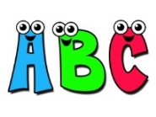 | Phonics/Spellings  Keep practising so you can remember your letters and digraphs quickly.  Have a go at learning to spell some of the tricky words stuck into your homework book. Here are some ideas to help you learn them.  1.Speedy Spellings! Read each word, then write them out as quickly as you can. You could time yourself, then try to beat your time!  2. Write the word using chalk or paint, or you could air write them.  3. Make the word out of playdoh.  4. Write your words like a rainbow. | Handwriting  Practise letter formation using the pre-cursive handwriting sheet stuck into your homework book.  Now write a word or sentence about King and Queens and still use the correct formation  When you feel confident, try to join your writing using pre-cursive. | Non-fiction writing  Can you research a famous monarch and write a fact file about him/her? We would love to hear any funny or interesting facts that you find out, and you can draw a picture of him/her to go with it.
Maths  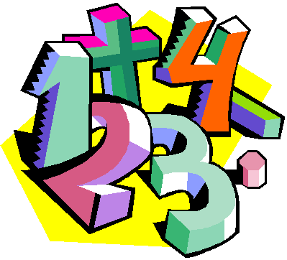 | Number facts  Practise forming your numbers correctly and the correct way round.  Practise counting in 1s and 2s. Can you count forwards and backwards?  Number bonds: To know number bonds to 10.  E.g., 7+3=10 2+8=10  Challenge: Number bonds to 20 | Maths Games  Can you play any board games at home where you need to count? Snakes and ladders is a good one. Or card games such as Uno. Can you recommend any other games to your class mates? | Problem solving  Use any method that you are confident with to help work out these problems.  -King George has lost 4 of his crowns. He should have 10 in total. How many does he still have?  -Queen Poppy is hosting a banquet. She has 6 guests arriving, but she only has 4 chairs around her table. How many more chairs does she need to find?  Can you think of your own maths problem, record it and ask a grown up or sibling to answer it for you!
Science  PSHE/Values | Materials  Can you go on a material hunt around your house? What are most objects made from? Why are certain objects made from a particular material? | Values  Our values in school are to be respectful, resilient and responsible.  Discuss with a grown up what they mean to you.  How can you show these values at home and in school? | PSHE  We are all different and all unique, which is what makes us who we are. Can you write about why you are unique? What are your special gifts?
Topic: Kings and Queens | Design and make  Could you design and make your own crown?  What about designing and creating a castle for a royal monarch to live in. | Geography  Can you research any famous landmarks in London that the Kings and Queens of the past/present have lived in or visited? | Art and Craft  Create a portrait of a famous monarch. You could use paint, pastels, sketching pencils or even collage materials.

